
School of Computer Science Engineering and Information System
(SCORE)
Winter Semester 2025-2026
Assessment-05

Name: DHAYA LAKSHMI A
Reg. No.: 24MIS0158
Programme/Branch: M. Tech., (SE)
Faculty Name: Dr Gunasekaran G
Course Code : ISWE207P
Course:Object Oriented Analysis and Design
Lab Lab Slot: L27+L28

Problem Statement 01: Online Food Ordering and Delivery System
An effective food ordering process is often hindered by traditional methods such as phone calls, long waiting times, and limited access to updated menus. Customers struggle with delays, miscommunication, and the inability to track their orders in real time. At the same time, restaurants face difficulties managing multiple orders, maintaining accurate records, and coordinating delivery activities efficiently. Manual handling often results in incorrect orders, slow service, and reduced customer satisfaction. Delivery personnel also encounter challenges in receiving timely updates and choosing optimal routes, which affects delivery speed. To address these issues, there is a need for a unified Online Food Ordering and Delivery System that streamlines ordering, enhances accuracy, improves communication, and ensures smooth and transparent experience for customers, restaurants, and delivery staff.

EXPERIMENT – 1

AIM:
The experiment aims to prepare a System Design Document for the project Online Food Ordering and Delivery System.

Steps for creating a State Chart Diagram

Step1. Identify the System
The system is an Online Food Ordering and Delivery System where users can:
- Register/Login
- Browse food
- Place orders
- Make payments
- Track delivery

Step2. Identify Initial and Final States
- Initial State: Start / User opens application
- Final State: Order delivered / Order completed

Step3. Identify Possible States
- Registration
- Login
- Browse Menu
- Add to Cart
- Checkout
- Payment Processing
- Order Confirmation
- Food Preparation
- Out for Delivery
- Delivered

Step4. Label Triggering Events
- User enters details
- User logs in
- Selects food items
- Clicks checkout
- Makes payment
- Restaurant accepts order
- Delivery partner picks order
- Order delivered

Step5. Draw the State Chart Diagram for an online order system with appropriate notations

Case 1: User Registration & Login

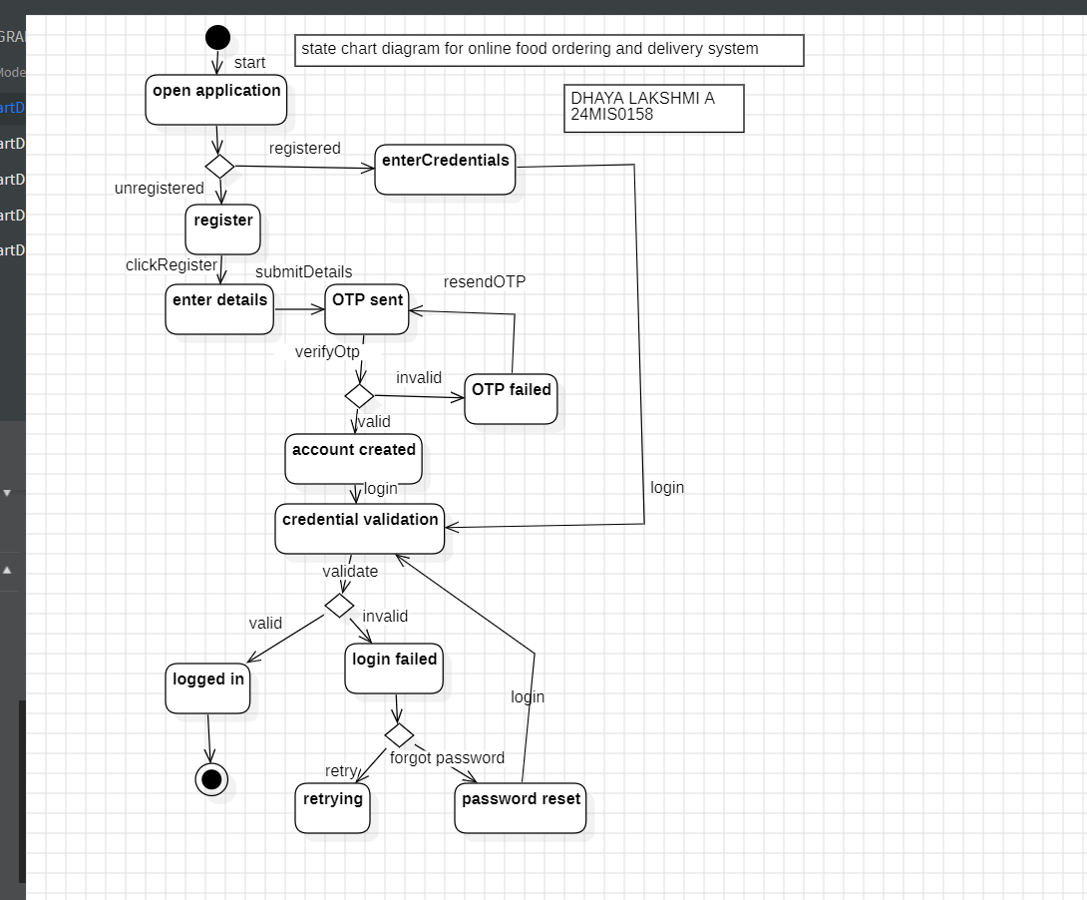

Case 2: Browse Menu & Add to Cart

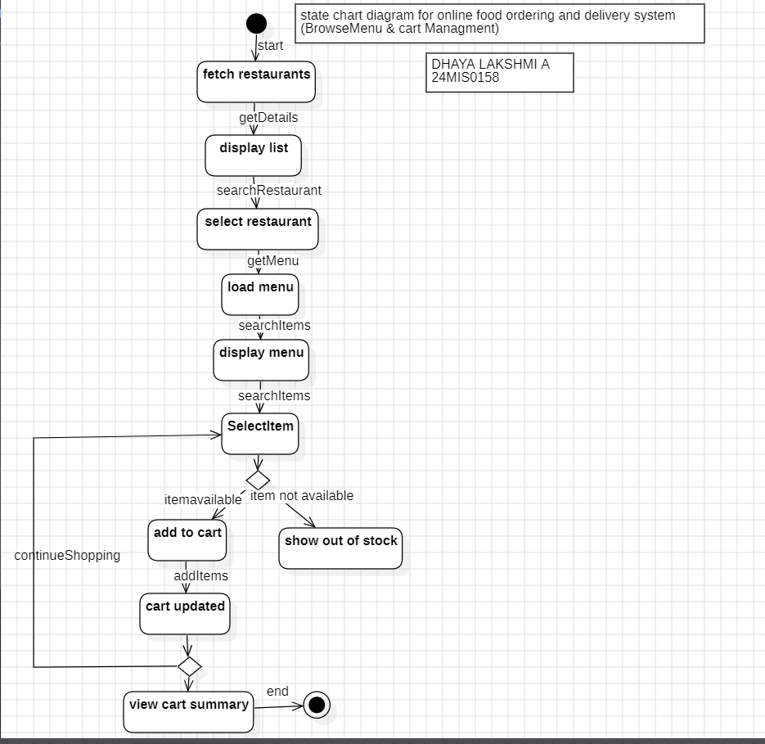

Case 3: Checkout & Payment

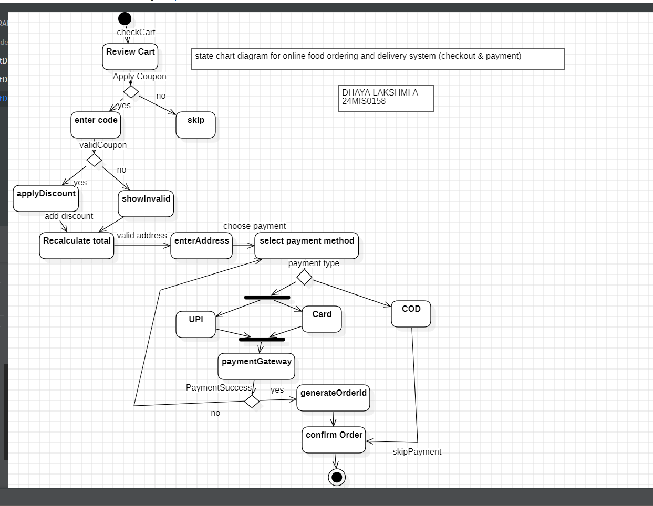

Case 4: Restaurant Processing

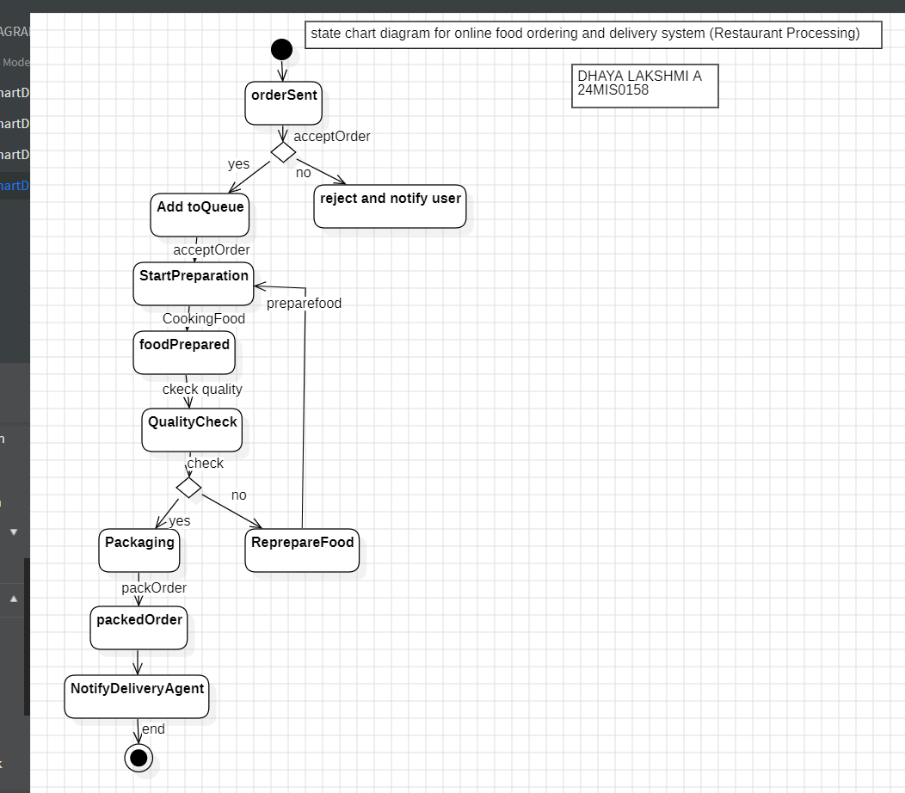

Case 5: Delivery Process

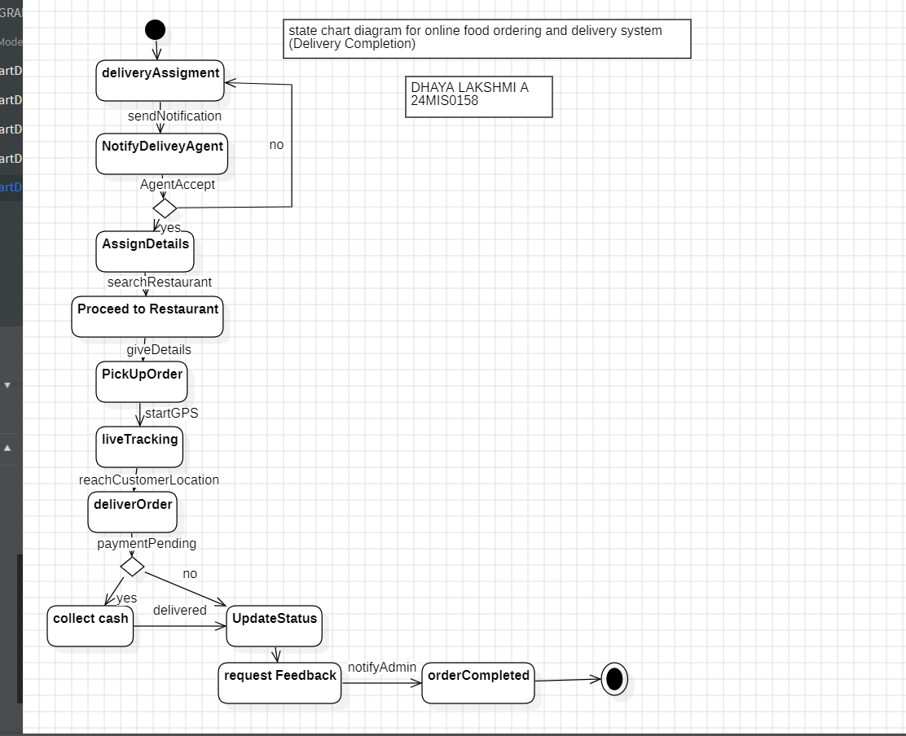

RESULT
Thus, the State Chart diagram for the Online Food Ordering and Delivery System project was designed using Star UML.

EXPERIMENT – 2

AIM:
To identify the Components and notations and draw a Deployment diagram for the project's Online Food Ordering and Delivery System

Steps for creating a Deployment Diagram:

Step 1: Identify Components
The components identified in the system are:
- Mobile Device (User App)
- User Interface (Registration, Menu Browsing, Ordering)
- Order Management System (Business Logic, API Services, Notification Services)
- Database Server (Order and User Data)
- Payment Gateway (Payment Processing)
- Restaurant System (Order Management)
- Delivery Partner (Delivery App)
- GPS Map Service (Location and Routing)

Step 2: Identify Relationships
The relationships between components are:
- Mobile Device communicates with Order Management via HTTPS.
- User Interface interacts with Order Management through UI Services.
- Order Management connects with:
- Payment Gateway via API.
- Database Server via SQL.
- Restaurant System via API.
- Delivery Partner via API.
- Delivery Partner interacts with GPS Map Service using GPS Data.

Step 3: Gather Requirements
- Real-time order placement and tracking.
- Secure and reliable payment processing.
- Fast communication between customer, restaurant, and delivery agent.
- Scalability to handle multiple users and orders.

Step 4: Draw Nodes and Component
The nodes identified in the deployment diagram are:
- Mobile Device.
- Server (Order Management System).
- Database Server.
- Payment Gateway.
- Restaurant System.
- Delivery Partner System.
- GPS Map Service.

The Components (Inside Nodes) identified in the deployment diagram are:
1. Mobile Device :
- User App.
2. User Interface :
- User Registration.
- Menu Browsing.
- Food Ordering.
3. Application Server (Order Management) :
- Business Logic.
- API Services.
- Notification Services.
4. Database Server :
- Order and User Data.
5. Restaurant System:
- Order Management.
6. Payment Gateway:
- Payment Processing.
7. GPS Map Service:
- Location and Routing.
8. Delivery Partner:
- Delivery App.

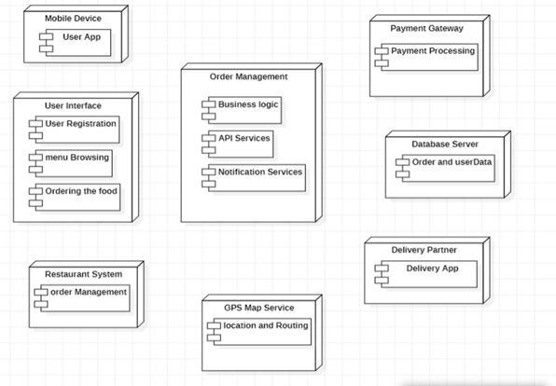

Fig 2.1 : Deployment diagram for online food ordering and delivery system(without connecting nodes).

Step 5: Connect Nodes and Components
- Mobile Device is connected to Order Management using HTTPS
- User Interface is linked to Order Management via UI Services
- Order Management is connected to:
- Payment Gateway (API)
- Database Server (SQL)
- Restaurant System (API)
- Delivery Partner (API)
- GPS Map Service is connected to Delivery Partner for navigation

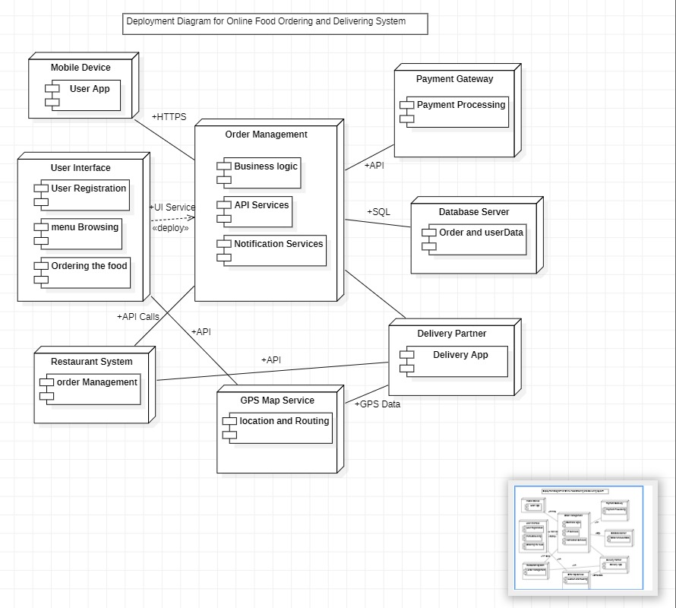

Fig 2.2 : Deployment diagram for online food ordering and delivery system

Step 6: Add Details
      - Communication through the Internet (HTTP/HTTPS)
      - APIs used for communication
      - transactions (SSL)
      - GPS tracking for delivery

Step 7: Documentation
The deployment diagram is documented with all nodes, components, and their interactions clearly labeled. It provides a complete view of the system architecture, showing how different parts of the Online Food Ordering and Delivery System are deployed and communicate with each other.

RESULT
Thus, the Deployment diagram for the Online Food Ordering and Delivery System project was designed using Star UML.

EXPERIMENT – 3

AIM:
To identify the Functional Components and draw the Component diagram for the project's Online Food Ordering and Delivery System

Steps for creating a Deployment Diagram:

Step 1: Identify the System Scope and Requirements
The system is an Online Food Ordering and Delivery System which allows users to search food items, add them to cart, place orders, make payments, and track delivery. It also includes restaurant management and admin control functionalities.

Step 2: Identify and Define Components
The components identified from the diagram are:
- User Management Component:
- Handles user activities (login, search, interaction).
- Search and Delivery System Component:
- Handles food searching and initial delivery interaction.
- Order Management Component:
- Manages order creation, update, and status.
- Payment System Component:
- Processes online payment transactions.
- Delivery Management Component:
- Handles delivery tracking and location updates.
- Restaurant Management Component:
- Manages restaurant details and order processing.
- Admin Portal Component:
- Manages system data and restaurant details.
- Notification System Component:
- Sends order status and updates to users.

Step 3: Identify Provided and Required Interfaces
The interfaces shown in the diagram include:
User Management:
- Provides: Search food items, Transaction details, Location
- Requires: Search System, Payment System, Delivery Management
Search and Delivery System:
- Provides: Add to cart
- Requires: Order Management
Order Management:
- Provides: Order details
- Requires: Delivery Management, Restaurant Management, Notification System

Payment System:
- Provides: Payment processing
- Requires: Restaurant Management
Delivery Management:
- Provides: Delivery tracking
- Requires: Order Management
Restaurant Management:
- Provides: Restaurant details
- Requires: Payment System, Admin Portal
Admin Portal:
- Provides: Management details
- Requires: Restaurant Management
Notification System:
- Provides: Notification services
- Requires: Order Management

Step 4: Identify Relationships and Dependencies
User Management depends on:
- Search and Delivery System
- Payment System
- Delivery Management
Search and Delivery System depends on:
- Order Management
- Order Management depends on:
- Delivery Management
- Restaurant Management
- Notification System
Payment System depends on:
- Restaurant Management
Admin Portal depends on:
- Restaurant Management

Step 5: Identify Artifacts
In this component diagram, artifacts correspond to the data handled by components such as:
- User Management → User data and interaction details.
- Search and Delivery System → Search results and cart data.
- Order Management → Order records.
- Payment System → Transaction records.
- Delivery Management → Delivery and location data.
- Restaurant Management → Restaurant information.
- Admin Portal → Management data.
- Notification System → Notification messages.

Step 6: Identify Nodes
Although nodes are mainly used in deployment diagrams, logically the system can be considered to run on:
- Client side (User Management)
- Application server (Order, Payment, Delivery systems)
- Database server (stores system data)

Step 7: Draw the Diagram

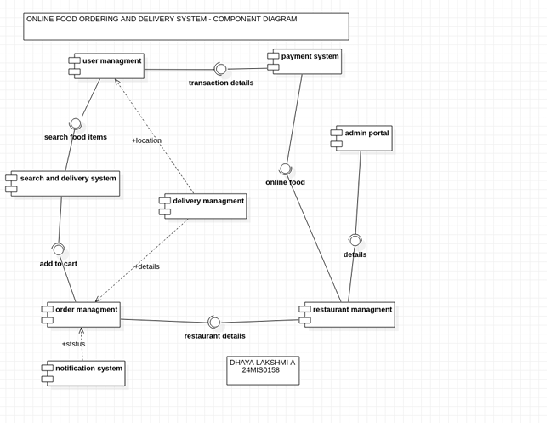

Fig 3.1: component diagram for online food ordering and delivery system.

Step 8: Review and Refine the Diagram
The diagram is reviewed to ensure all components, interfaces, and relationships are correctly represented and aligned with system requirements. Necessary refinements are made for clarity and completeness.

RESULT
Thus, the Component diagram for the Online Food Ordering and Delivery System was designed using Star UML

